# InfoSelHandler 2.0

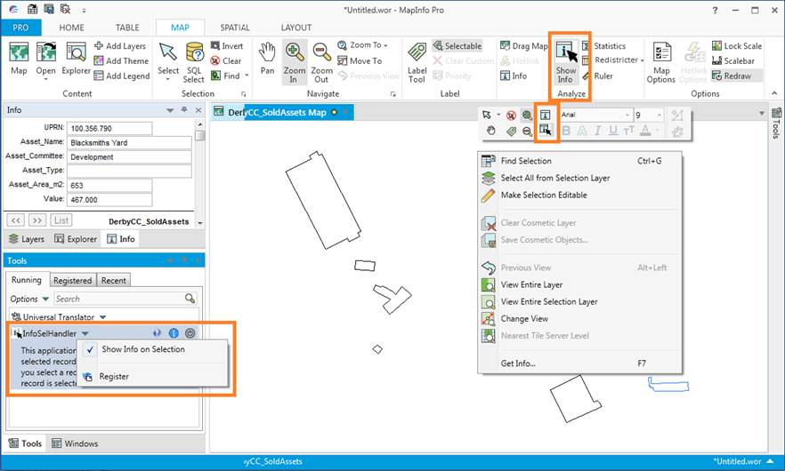

# Install InfoSelHandler

You install InfoSelHandler by downloading the InfoSelHandler.zip file. Extract the files into a new folder or into the folder with your other MapInfo tools.

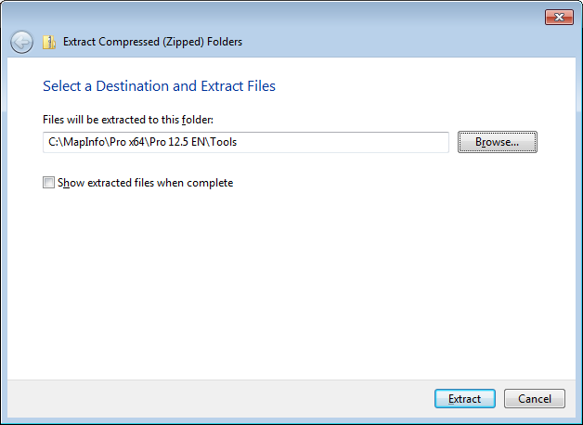It is recommended to install InfoSelHandler into its own folder and not install it directly into for example the tools folder.

With InfoSelHandler 2.0 you can use the standard Extract function in Windows 7 and just pick the location to unzip the file. The zip file contains a sub folder and so InfoSelHandler will get installed into its own subfolder.

## Add tool to Tool Manager

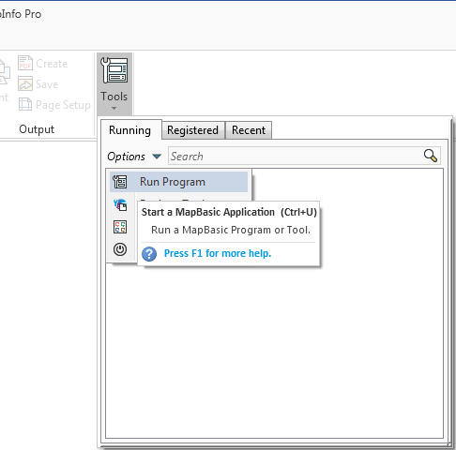Go to Home > *Tools* and click on the *Run Program* in the *Options* menu.

Now navigate to the location where you unzipped InfoSelHandler and select the file InfoSelHandler.mbx.

Once the tool has been loaded you can go back to the Tools and click on context menu of InfoSelHandler in the list of Running tools.

Then click on *Register* to add InfoSelHandler to the list of registered tools.

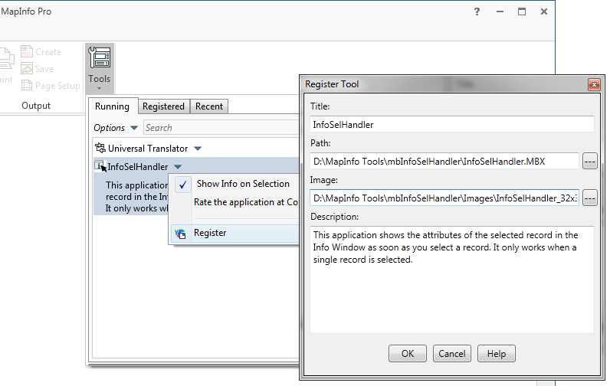

Notice that the values have been prefilled for you so you just have to hit OK to add InfoSelHandler to the list of tools.

Click *OK*. Go back to the *Tools* window select the Registered tab to see the registered tools. Here you can check the *Autoload* checkbox for this tool to load it whenever MapInfo Pro starts up.

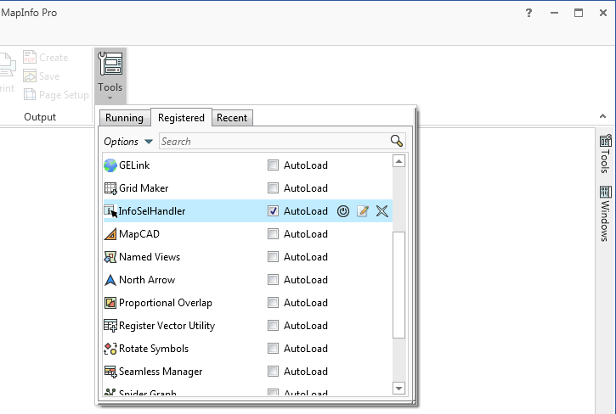

# The features

InfoSelHandler only has a single feature:

* It can show the attributes of the selected/deselected record in the Info tool window

Basically, you only have to select or deselect an object and the InfoSelHandler tool will immediately show the attributes of this record in the Info tool window.

If you are running InfoSelHandler on MapInfo Pro x64 it will also add the Info tool to the Map MiniToolbar

You can enable/disable the feature via a few ways:

* On the *MAP* tab in the *Analyze* group, click *Show Info* to enable/disable SelInfoHandler
* In the *Tools* window, on the context menu on the SelInfoHandler tool, click *Show Info on Selection* to enable/disable SelInfoHandler
* On the Map MiniToolbar click on the Show Info button to enable/disable SelInfoHandler



# Languages

InfoSelHandler allows the user to switch between a number of languages.

The number of languages can be extended by the user himself, see further down.

### Switching language

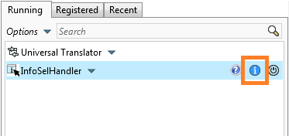To switch language you simple go to the Tool window and locate InfoSelHandler in the list. Now click on the Info icon.

In the About dialog you can see the available languages in the dropdown list.

You can pick any of the available languages.

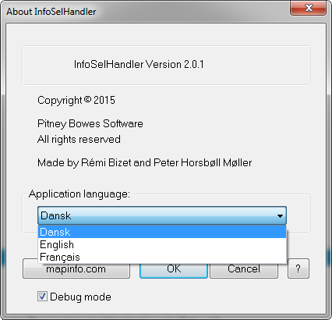

When you click a different language, do note that the language used will not change in the menus until you restart InfoSelHandler.

### Adding your own language

You can add you own language if you like simply by creating a copy of one of the existing language files (*.str) that you can see in the Folder called *Strings* in the folder where you installed InfoSelHandler.

You can name your language file whatever you want. I would recommend that you name it like the name of the language, German.str, Greek.str and so on.

Now open the new language file in a text editor and translate the existing strings.

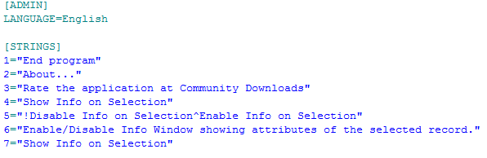Make sure that you also change the name of the language in the top of the language file.

Save the changes and restart InfoSelHandler. The new language will now be available in the about box.